Request for Quotation (RFQ)
Title of the service required | Manufacturing and Installation of Metal Leaf Composter at RZP Schools in Uran & Panvel (8 Schools)
Brief explanation of the product/service required | Metal leaf composter of (4’x4’x5’) (*l*b*d) with 2 openings and 2 coats of corrosion resistance painting (preferably green)  1) Front face (outlet for compost) -1 Sft.  2) Top face opening (inlet for leaf) – 4’x4’ Sft  3) Supporting legs (MS material) of 1’ ft– 4 no’s to be placed in 0.5 Cft of M15 grade concrete during installation.  4) Provision for lock to be made for Metal leaf composters.
Specification of the product/type of service | Fabrication and Installation of MS leaf Composter as per given Drawing in and delivering it at TIDE specified school.  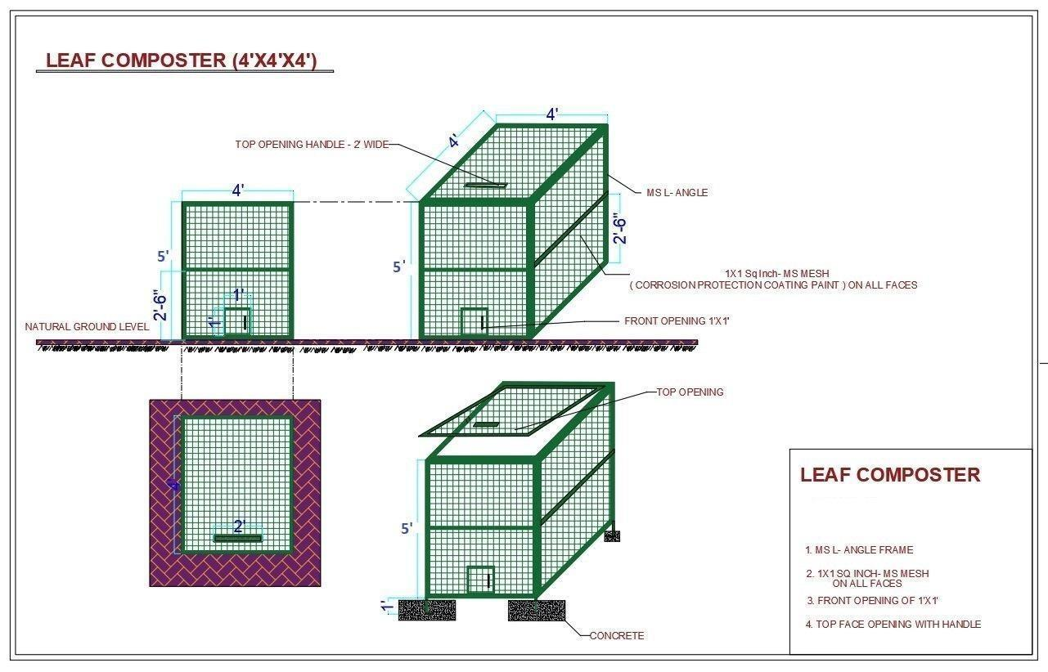
Quantity | Total Schools Covered: 08
  Sr. No. | School Name
  1 | RZP School Ovepeth
  2 | RZP School Bamandongari
  3 | RZP School Kalamboli
  4 | RZP School Karanjade
  5 | RZP School Bhendkhal
  6 | RZP School Vindhane
  7 | RZP School Mulekhand
  8 | RZP School Owecamp
Additional details | - Requesting quotation with timeline and details of materials, specifications, and fabrication.  - Vender takes full responsibility of Manufacturing, delivering and installation of the products at TIDE specified location without any damage and contingencies.  - Materials of superior quality to be used in fabrication work.  - Damaged Products will not be accepted, Vendor is responsible for replacing it with new products within 3 working days
Submission Requirements | A. Details  • Item-wise cost (material + labour + transport)  • Training / installation cost (if any)  • GST and validity of quotation  • Delivery timeline  B. Vendor Details  • Contact person name & phone number  • PAN / Aadhaar  • GST / Udyam (if available)  • Brief experience or previous work (optional)
Shipping/Service address
  Sr. No. | School Name | Locations/Co-ordinates
  1 | RZP School Ovepeth | https://maps.app.goo.gl/D6K4324j6tCngAGe7
  2 | RZP School Bamandongari | https://maps.app.goo.gl/A2pFe5Lf9DQ8kKAaA
  3 | RZP School Kalamboli | https://maps.app.goo.gl/kG4ddCqtjgoGn6f8A
  4 | RZP School Karanjade | https://maps.app.goo.gl/ADpeH1hDTDCk6xnP9
  5 | RZP School Bhendkhal | https://maps.app.goo.gl/wvPoSZSjJ87pr9jd9
  6 | RZP School Vindhane | https://maps.app.goo.gl/dZ2f6eTQvpMkQ8Ai6
  7 | RZP School Mulekhand | https://maps.app.goo.gl/PpgRMrNoBLkFuPQ6A
  8 | RZP School Owecamp | https://maps.app.goo.gl/7PB8F7AVngZ4HV738
Deadline for receiving the quotation (mail or hard copy as stated in terms below) | 08/12/2025

Evaluation Criteria
All submitted quotations will be evaluated based on the following criteria
- Technical Compliance (40%)
  - Adherence to the required specifications
  - Quality of materials and build
  - Safety features
  - Warranty period
  - Availability of installation and training support
- Financial Proposal (30%)
  - Total cost (inclusive of taxes and delivery)
  - Cost-effectiveness in comparison to other bids
  - Transparency of pricing (no hidden charges)
- Vendor experience and Capability (15%)
  - Experience in supplying similar equipment
  - Past performance with government/NGO/municipal clients
  - Technical expertise and competent service team
- After-Sales Service & Support (10%)
  - Availability of service centre or on-site support
  - Response time for maintenance
  - AMC (Annual Maintenance Contract) options
- Delivery Timeline (5%)
  - Ability to deliver and install within the required timeframe

Payment Terms
- Advance Payment (50%)
  - 50% of the total contract value will be released as advance
  - Only upon submission of a Bank guarantee or a Security Cheque equivalent to the advance amount.
- Delivery Payment (30%)
  - 30% of the payment will be released after the successful delivery of the materials and completion of implementation and workshop at Five designated schools.
  - Subject to verification of condition and conformity with specifications.
- Installation Payment (20%)
  - 20% will be released after successful installation, testing and demonstration of the machine’s full functionality.

Required documents
- Tax invoice
- Delivery challan
- Installation & Commissioning pictures
- Warranty certificate

Payment Method
Payment will be made through bank transfer to the vendor's registered bank account.

Submission Method

Submission of quotes
All quotations must be submitted electronically to the designated email: procurement@tide-india.org with subject line “Quotation for Manufacturing and Installation of Metal Leaf Composter at RZP Schools in Uran & Panvel (8 Schools)”
Submission must include the technical proposal, financial proposal, and all required supporting documents. Late submissions will not be considered.

Deadline for submission
All quotation must be submitted on or before 08.12.2025

Queries and Clarifications
Vendors may submit any questions or clarification requests to: info@tide-india.org. All queries must be sent on or before 08.12.2025

ANNEXURES

Annexure I: Letter for EOI Submission to Be Submitted on the Letter Head of the Institution
Annexure II: Information regarding any Conflicting activities and declaration
Annexure III: Details of a minimum of 3 similar works executed by the bidder.
Annexure IV: Quote/Bid FORM
Annexure V: Specification and details of the equipment

ANNEXURE I
LETTER FOR EOI SUBMISSION TO BE SUBMITTED ON THE LETTERHEAD OF THE ORGANISATION

Ref: No: Date:
Executive Director,
TIDE, FF-1, Sapthagiri Apartments,
No.30, 10th Cross, 15th Main Road,
RMV Extension, Sadashiv Nagar,
Bengaluru – 560080

Dear Sir/Madam
We, the undersigned, offer to provide the services as required in your invitation for EOI dated: -------------. We are hereby submitting our proposal with all the requisite information and documents.
We hereby certify that all the information and statements made in this proposal are true and accept that any misstatement or misrepresentation in the enclosed documents may lead to our disqualification.
We understand that you are not bound to accept/reject any proposal without assigning any reason.
Yours faithfully

Authorized Signatory
NAME & DESIGNATION

ANNEXURE II
INFORMATION REGARDING ANY CONFLICTING ACTIVITIES AND DECLARATION THEREOF

Is the party engaged in any activities which conflict with the proposed activities of TIDE as mentioned in this document?

If yes:
Please furnish information on activities the institution is engaged in, which in your opinion, is of a nature that conflicts with the assignment desired to be awarded by CoE.

If no:

We hereby declare that our organization is not either directly or indirectly engaged in any activities which can be termed conflicting activities as mentioned in the EOI document. It is understood that any misrepresentation or misstatement in this regard shall lead to our organization to be disqualified from the entire process.

Signature of the authorized signatory
Name
Designation

TO BE SUBMITTED ON THE LETTERHEAD
ANNEXURE III
Details of a minimum of 3 similar works executed.
(Amount Rs. in Lakh)
Sl.No. | Nature of similar work carried out | Name of the party for whom such work was carried out | The total value of the work | Period of the assignment | Contact person name and mobile no.

AUTHORISED SIGNATORY

TO BE SUBMITTED ON THE LETTERHEAD
ANNEXURE IV
Quote/Bid FORM
To
The Executive Director
TIDE
FF-1, Sapthagiri Apartments, No. 30, 10th Cross, 15th Main Rd,
Raj Mahal Vilas Extension, Sadashivanagar,
Bengaluru, 560080

I hereby offer to submit our EOI for the “……………………………………………………………………………………..” assignment as a Service Provider/Expert/supplier of material/services etc.
Sl No. | Parameters | Particulars/Description
 | Name
 | Address
 | Contact Details | Email:  Mobile:
 | Total Lumpsum Cost/Fee (in Rupees) Inclusive of GST for work completed as per ToR
 | GST Number (If no GST please submit a declaration)
Note: Site Visits charges will not be reimbursed
Declaration:
I certify that the above particulars are correct. I understand and agree that if any statement is found to be false or incorrect, TIDE reserves the right to reject my application.
I certify that if awarded the assignment, I shall maintain confidentiality and shall avoid.
conflict of interests.

Signature: Place:

Full name: Date:

TO BE SUBMITTED ON THE LETTERHEAD
Annexure V
Specification and details of the equipment

